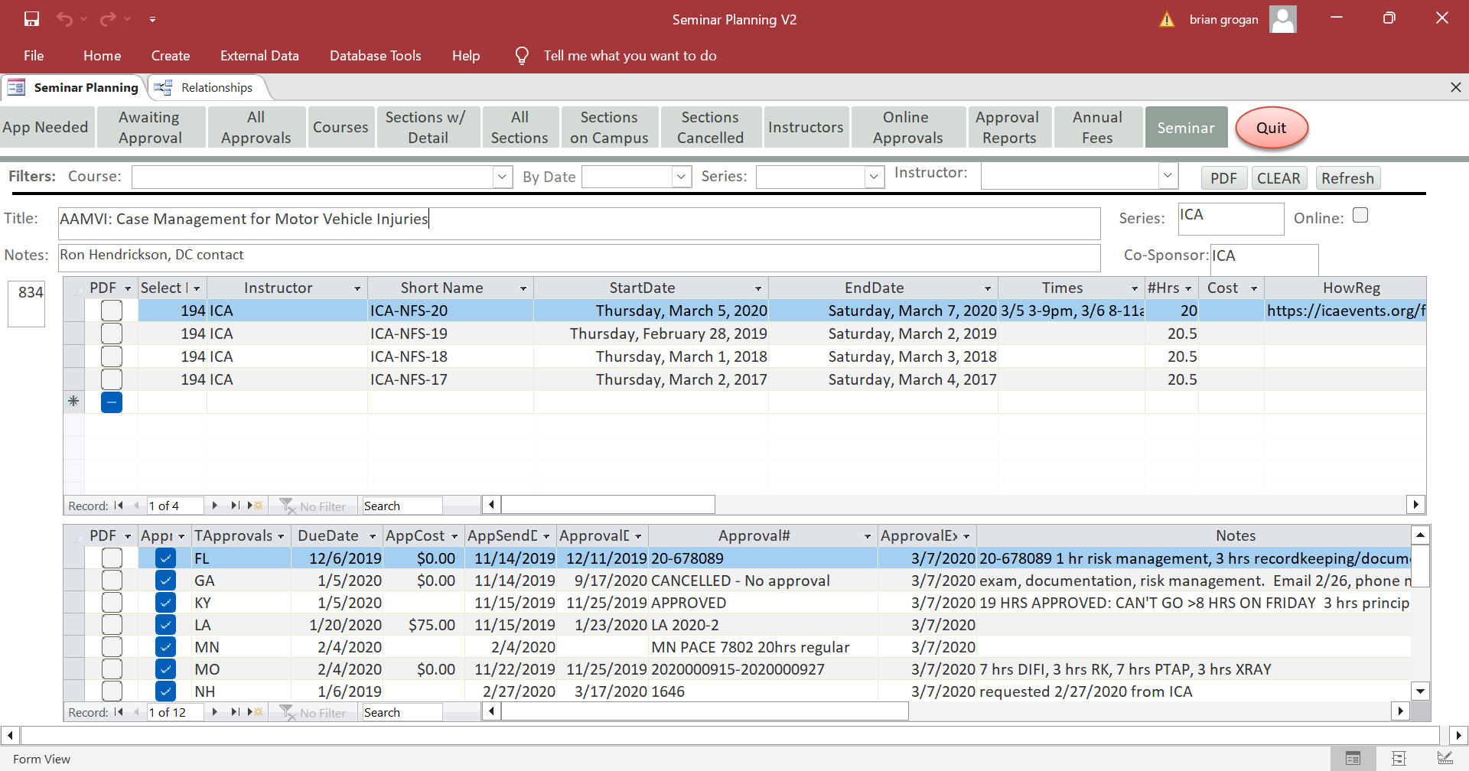
The Seminar (Tab shown dark grey) form contains at the top course information.
The Middle grid contains the sections available for the course selected
The lower grid represents the sections that have been approved
There is a one-to-many relationship between Courses table to the Sections table
There is a one-to-many relationship between Sections table and the Approvals table.
The Seminar form is used to produce PDF files. An entire section can be selected by clicking the PDF check box (Section Grid (middle grid) left had side, or individual states that have approved the course can be selected by clicking the PDF check box (Approval) Lower grid.
The PDF button top right of form when clicked will produce PDF reports for all courses.

Logic / Code to produce PDF Reports.
Software Requirements: Adobe Pro
Module: Mod_Produce_State_PDF
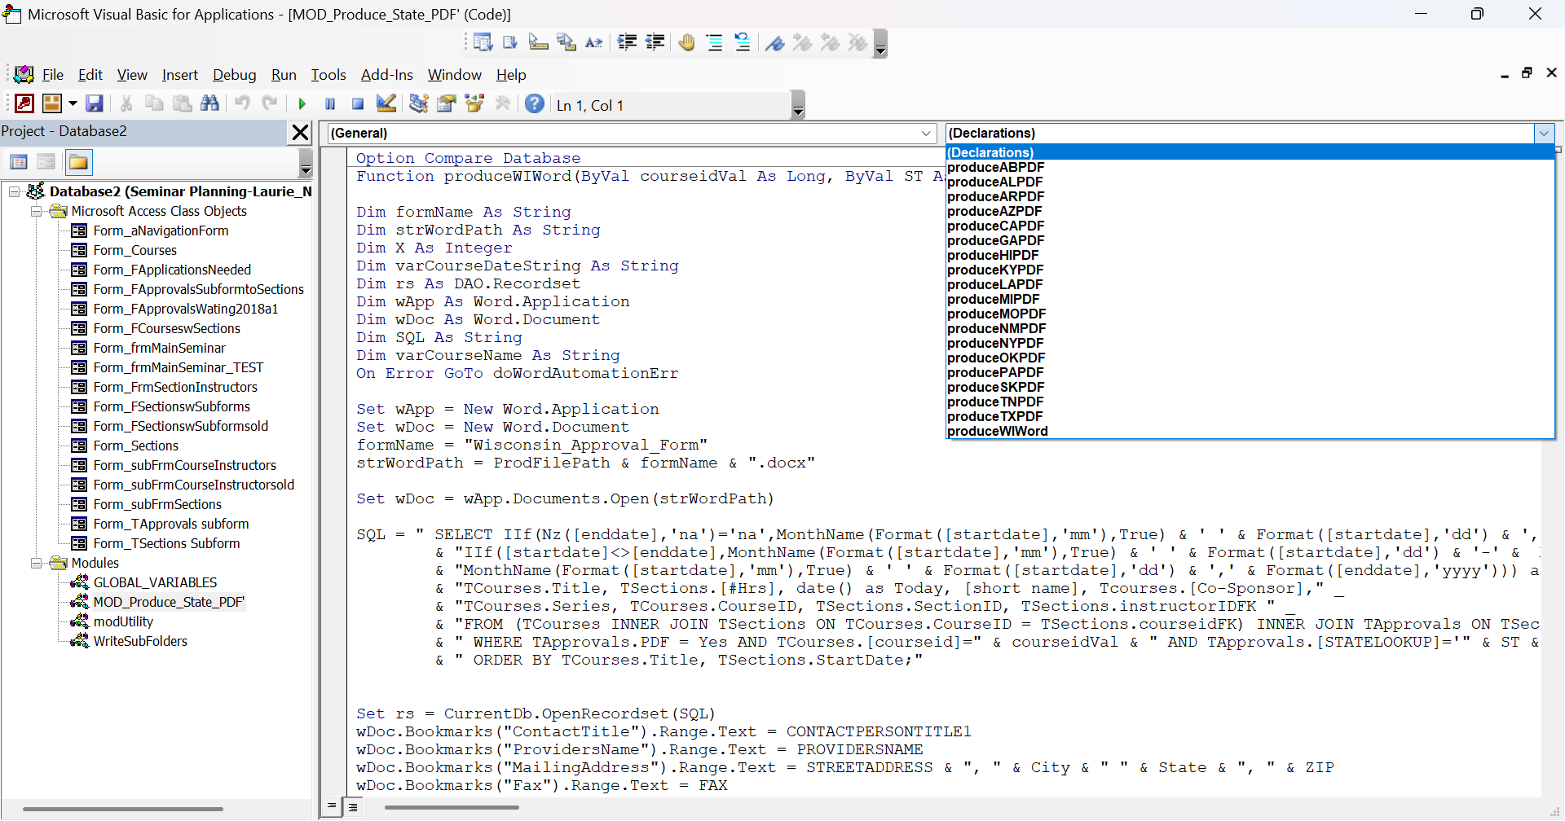
There are 18 Functions in the module.
I have included the code for one function in a document called produceNYPDF.
Each Function is passed a course ID and a State parameter. Dynamic SQL is built using the parameters to select the data from courses, sections and approval tables. When multiple sections are selected for the same state, the course information: date start, date end, Hours, and instructor is included in one PDF file eliminating the need to send multiple PDF files for the same course.

